Name 1:

Name 2: Group #:

Question # | Number of Points
1 – T/F and MC | /10
2 – Variables & Data Types | /10
3 – Lists & Loops | /10
Total | 30

Question #1
Total Points: (10) | 1 mark each
- Which of the following variable names is NOT valid in Python?
  - student_name
  - _score
  - 2ndPlace
  - totalMarks

- The input() function always stores the user’s input as a string.
  - True
  - False

- Which data type would best store the value 3.75?
  - int
  - str
  - float
  - Bool
- Which statement is correct regarding file input/output in Python?
  - readline() reads the entire file at once.
  - write() is used for reading from a file.
  - open() is only used for creating new files.
  - close() is not necessary when working with files.
- What will be printed by the following code? numbers = [2, 4, 6] print(numbers[1])
  - 2
  - 4
  - 6
  - Error

- Which statement correctly describes an if statement?
  - It repeats code a fixed number of times
  - It executes code only if a condition is true
  - It stores multiple values
  - It defines a function

- How do you access the value associated with the key 'age' in a dictionary named person?
  - person['age']
  - person.get('age')
  - person.value('age')
  - person[age]

- Which of the following creates an empty list?
  - list = ()
  - list = {}
  - list = []
  - list = ""
- What keyword is used to stop a loop immediately?
  - stop
  - break
  - exit
  - Continue
- What will be the output of this pseudocode? FOR i FROM 1 TO 10 DO
IF i MOD 3 = 0 THEN PRINT i
ENDIF ENDFOR
  - 3 6 G
  - 1 2 3 4 5 6 7 8 G 10
  - 0 3 6 G
  - 3 6 G 12

Question #2
Total Points: (10)

A library system is being created to track users and their borrowing activity.
The following code is part of the program:

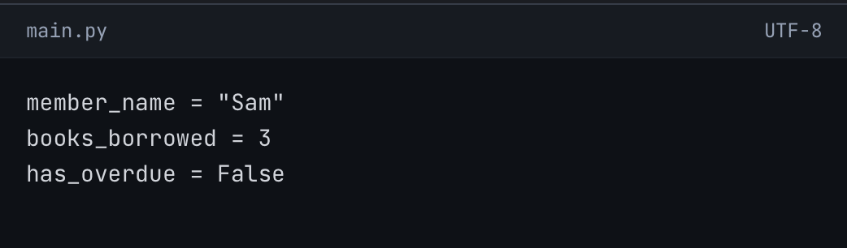

- (3 points) Identify the data type of each variable and briefly explain why that data type is appropriate for its use in this program.
- (2 points) Will this line of code run successfully?
  - If yes, explain what it does
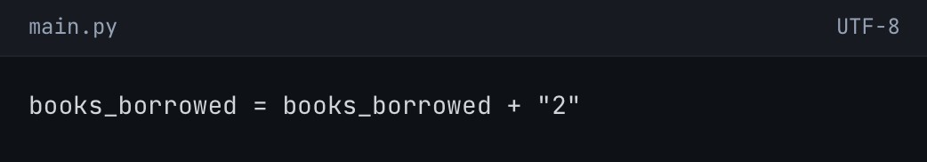
  - If no, explain why it causes an error in short.

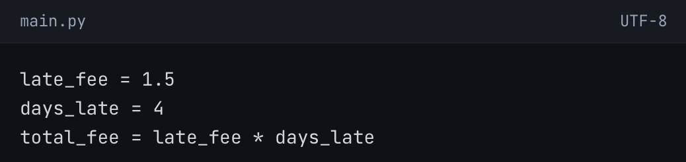
- (2 points) What is the value of total_fee, and what is its data type?

- (3 points) Rewrite one of the original variable names to make it
more descriptive, and explain your choice.

Question #3 : DICTIONARIES
Total Points: (10)
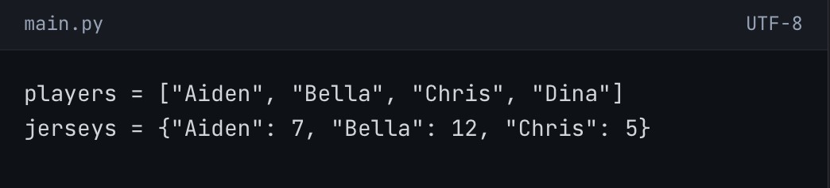
A sports club registration system stores player names and their jersey numbers.

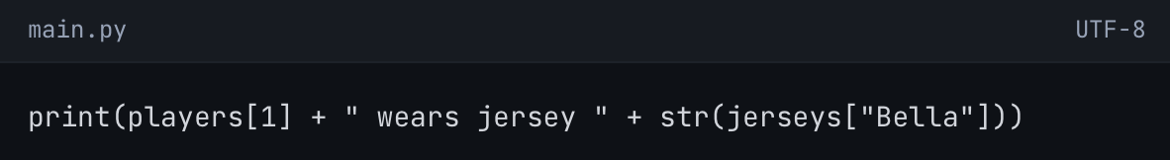
- (5 points) What will be printed by the following code?

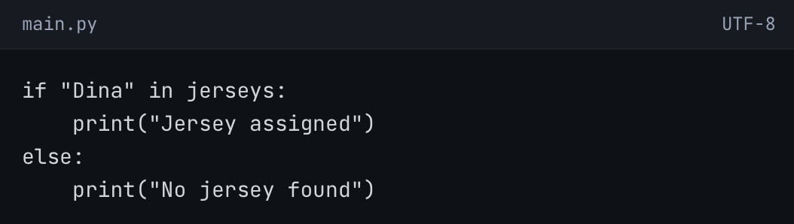
- (5 points) Explain what the following code does and give its output: (Hint: It’s in a dictionary)

